
To: WV STARS Professional Development (PD) Providers
From: WV STARS
Date: December 15, 2022
Re: Changes to the WV Registry System/Reminders

WV STARS PD Providers,

There are several newer features in the system and reminders I wanted to review with you:

- New Copy of WV STARS Policy Manual Available- There is a new copy of our Policy Manual available on our website, wvstars.org, on our home page:

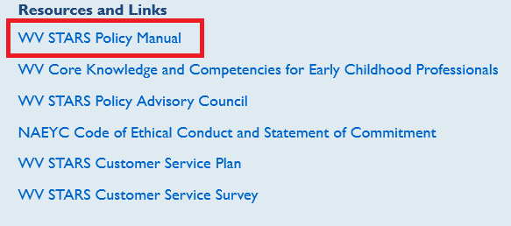

- We are currently working on an updated copy of the WV STARS Professional Development Provider Handbook. More details will be released later.

- Versioning Reminder- If you want to make changes to a pre-existing course, you MUST version it first to avoid messing up any previous enrollments. This includes adding/changing content, adding new modules, etc. When you version it, it will be resubmitted for publishing approval and must be approved before it is ready for use.

- Agenda Reminder- As I am completing Quality Assurance Reviews, I’m noticing some people are still leaving the agenda section of a scheduled event blank. Please note that the agenda needs to be included for all scheduled events on the Training Calendar. This is for multiple reasons; participants can see the agenda before they decide to register for an event. For details on what to include in an agenda, please see page 54 of the WV STARS PD Provider Handbook. Please make sure to include the necessary information for every scheduled event.

- Proof of Learning Reminder- All online courses require a Proof of Learning component and needs to be listed in the agenda section of a scheduled event. The purpose of the proof of learning is to encourage participation, interaction, and engagement in webinars and allow participants to show what they’ve learning. It doesn’t have to be a formal learning assessment (but can be). We encourage you to consider your audience when you create your proof of learning trainings, considering they are accessed by participants with a variety of backgrounds, skill levels, and knowledge bases. ​Some example proofs of learning include: ​an assessment through your webinar software​, an assessment using the WV STARS Registry Assessment module, reviewing webinar reporting data for participation statistics​, linking to an outside survey that is reviewed​, discussions, or an assignment that is reviewed.​

- “Add New Course” button when creating a new Scheduled Event: When creating a new Scheduled Event, there is a “Add New Course” Option (see below). If you are scheduling an event for a course that’s already been created and approved, you do not want to select this as it will create a completely new course. Instead, you will select the “Next” option as seen below. We are working with our support team to get this moved/resolved to avoid confusion.

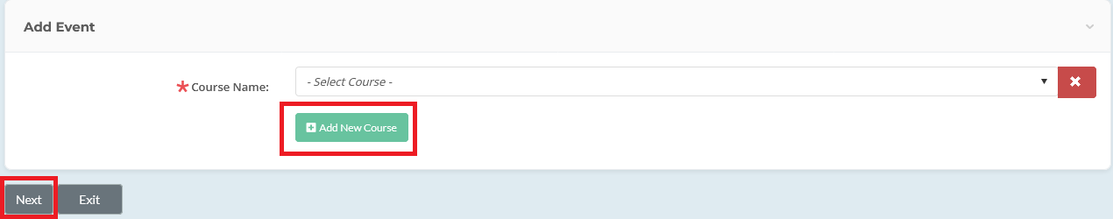

Please contact me with any questions you may have.
Thank you,
Stacy Price, MS  WV STARS Training Specialist  WV State Training and Registry System (WV STARS)  www.wvstars.org  www.facebook.com/wvstars | 611 Seventh Avenue, Suite 322  Huntington, WV 25701  T: 304-522-7827 x3471  F: 304-529-2535  sprice@rvcds.org

Administered by WV Early Childhood Training Connections and Resources, a program of River Valley Child Development Services “Serving Children and Families since 1971”.

